TASK-1
Understand the Problem and Identify the Data 4 Marks Bloom’s Level: K4 – Analyze the billing problem and identify every item of data the program must store and compute. Discuss: • The inputs (previous reading, current reading, household number, category) and the outputs (units, energy charge, fixed charge, total) • Which values never change during a run and should be constants • Which values can be negative, fractional or very large • The rules every correct bill must satisfy (for example: a bill is never negative;
the total equals the sum of its parts) • Any assumptions you make
#include <stdio.h>
#include <string.h>
int main(void) { printf("%d %d\n", (int)sizeof(unsigned short), (int)(strlen("01530") + 1));
return 0;
}
Output :
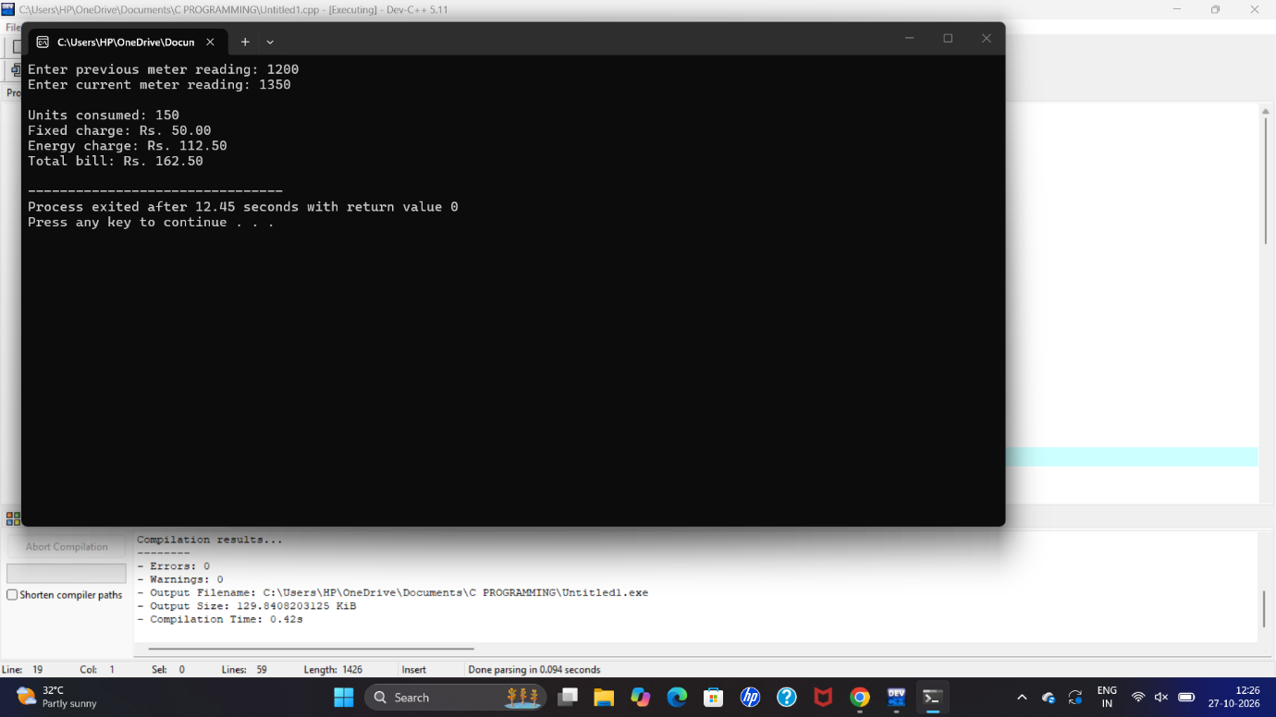

Task 2- Choose the Data Types 4 Marks Bloom’s Level: K4 – Analyse Select a C data type for every data item identified in Task 1. Discuss: • The type chosen (char, short, int, long, long long, unsigned, float, double) and its size using sizeof on your system • The range of each type using limits.h and float.h, and whether it is sufficient for a district • Why money should not be stored as float rupees, and the alternative of storing paise in an integer • What happens to a 16-bit unsigned meter register after 65535
#define __USE_MINGW_ANSI_STDIO 1
#include <stdio.h>
#include <limits.h>
#include <float.h>

int main(void)
{
int i;
float total_float = 0.0f;
long total_paise = 0;
unsigned short m = 65535;

printf("=== Part A: sizes and ranges on this system ===\n");
printf("%-20s %-6s %-26s %s\n",
"Type", "Bytes", "Minimum", "Maximum");

printf("%-20s %-6zu %-26d %d\n",
"char", sizeof(char), CHAR_MIN, CHAR_MAX);

printf("%-20s %-6zu %-26d %d\n",
"short", sizeof(short), SHRT_MIN, SHRT_MAX);

printf("%-20s %-6zu %-26d %u\n",
"unsigned short", sizeof(unsigned short), 0,
(unsigned)USHRT_MAX);

printf("%-20s %-6zu %-26d %d\n",
"int", sizeof(int), INT_MIN, INT_MAX);

printf("%-20s %-6zu %-26d %u\n",
"unsigned int", sizeof(unsigned int), 0, UINT_MAX);

printf("%-20s %-6zu %-26ld %ld\n",
"long", sizeof(long), LONG_MIN, LONG_MAX);

printf("%-20s %-6zu %-26lld %lld\n",
"long long", sizeof(long long), LLONG_MIN, LLONG_MAX);

printf("%-20s %-6zu %-26e %e\n",
"float", sizeof(float), FLT_MIN, FLT_MAX);

printf("%-20s %-6zu %-26e %e\n",
"double", sizeof(double), DBL_MIN, DBL_MAX);

printf("float digits of precision: %d, double: %d\n",
FLT_DIG, DBL_DIG);

printf("\n=== Part B: float rupees vs integer paise, 4000 bills of Rs 162.35 ===\n");

for (i = 0; i < 4000; i++) {
total_float += 162.35f; /* money as float rupees */
total_paise += 16235L; /* money as integer paise */
}

printf("Float total : Rs %.2f\n", total_float);
printf("Paise total : Rs %ld.%02ld\n",
total_paise / 100, total_paise % 100);
printf("Correct total : Rs 649400.00\n");

printf("Float error : Rs %.2f\n", total_float - 649400.0f);

printf("\n=== Part C: 16-bit register rollover ===\n");
printf("65535 + 1 stored in unsigned short = %u\n",
(unsigned)(unsigned short)(m + 1));

getchar();
return 0;
}
Output :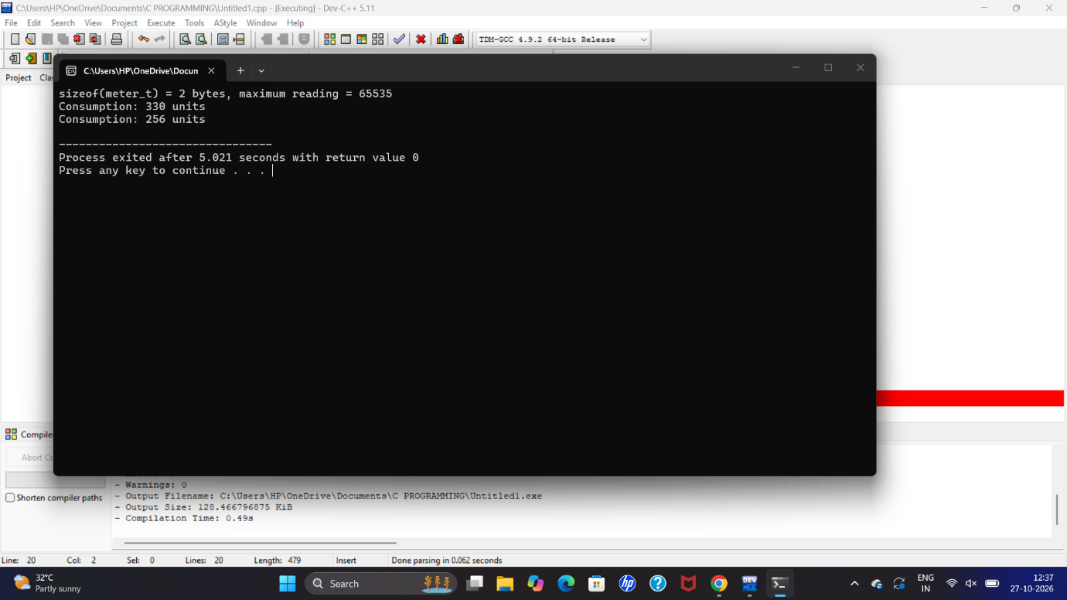

Task 3-
TASK 3 – Define the Constants (3 Marks)
Questions
Define tariff values and limits using constants.
Explain #define, const, and Enum.
Compare type checking, scope, debugging, and memory usage.
Follow appropriate constant naming conventions.
Complete the billing function using the provided macros.
Change RATE2_PAIS to 230 and verify the updated bills.
Compare constants implemented using macros, const variables, and enums.
#include <stdio.h>

#define RATE1_PAIS 150
#define RATE2_PAIS 230
#define MAX_UNITS 1000

const int LIMIT = 500;

enum Rate {
BASIC = 100,
STANDARD = 200,
PREMIUM = 300
};

int billing(int units, int rate)
{
return units * rate;
}

int main(void)
{
int units = 10;
int bill;

bill = billing(units, RATE2_PAIS);

printf("Units = %d\n", units);
printf("Rate = %d paise\n", RATE2_PAIS);
printf("Bill = %d paise\n", bill);
printf("Limit = %d\n", LIMIT);
printf("Premium rate = %d\n", PREMIUM);

return 0;
}
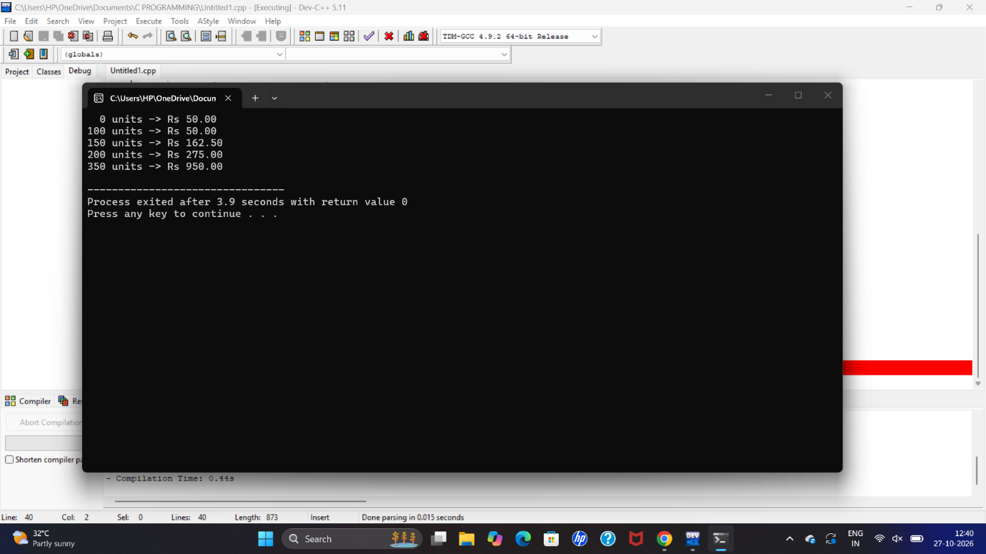

Task 4-
TASK 4 – Use Macros Safely (4 Marks)
Questions
Create macros for repeated calculations, such as rupees-to-paise conversion and finding the maximum value.
Demonstrate macro expansion using gcc -E.
Explain why SQUARE(x) without parentheses produces incorrect results.
Explain how MAX(a,b) may evaluate arguments more than once.
Identify situations where functions are better than macros.
Compare macros with static inline functions in terms of execution time and code size.
#include <stdio.h>

#define RUPEES_TO_PAISE(x) ((x) * 100)
#define SQUARE(x) ((x) * (x))
#define MAX(a,b) ((a) > (b) ? (a) : (b))

static inline int square(int x)
{
return x * x;
}

int main(void)
{
printf("Paise = %d\n", RUPEES_TO_PAISE(50));
printf("Square = %d\n", SQUARE(5));
printf("Maximum = %d\n", MAX(10, 20));
printf("Inline square = %d\n", square(5));

return 0;
}
Output :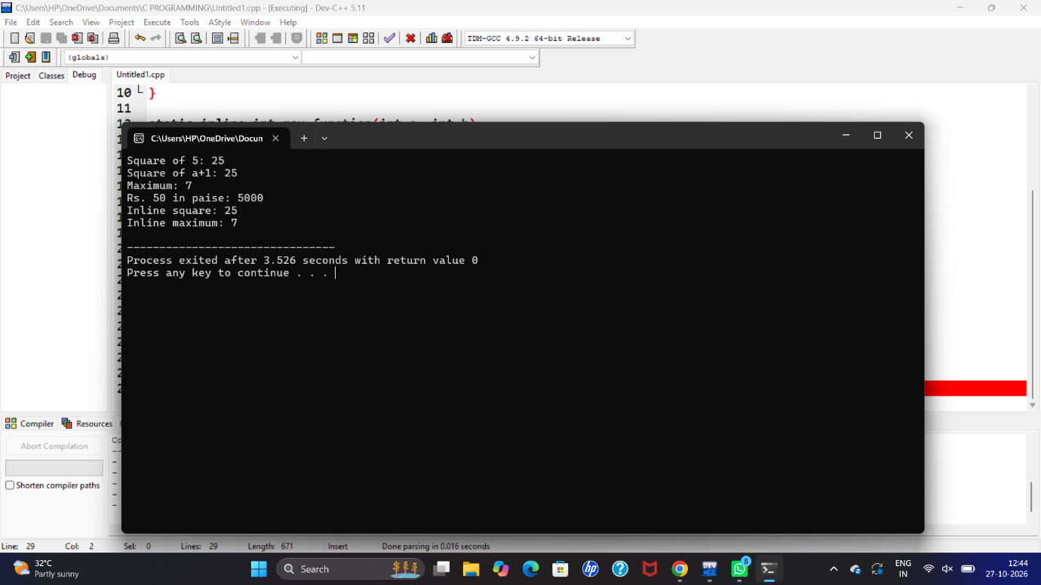

Task 5-
TASK 5 – Organise the Program with Header Files and Conditional Compilation (3 Marks)
Questions
Organise constants and function prototypes into header files and implement debugging support.
Explain the structure of a C program.
Implement include guards using #ifndef, #define, and #endif.
Implement conditional debugging using #ifdef DEBUG and gcc -DDEBUG.
Explain the difference between #include <file> and #include "file".
Compare compile-time debugging with runtime debugging in terms of time and executable size.
#include <stdio.h>

#define RATE 200

#ifndef LIMIT
#define LIMIT 1000
#endif

#ifdef DEBUG
#define DEBUG_PRINT(x) printf("DEBUG: %s\n", x)
#else
#define DEBUG_PRINT(x)
#endif

int billing(int units, int rate);

int billing(int units, int rate)
{
return units * rate;
}

int main(void)
{
int units = 10;
int bill;

DEBUG_PRINT("Program started");

bill = billing(units, RATE);

printf("Units = %d\n", units);
printf("Rate = %d\n", RATE);
printf("Bill = %d paise\n", bill);
printf("Limit = %d\n", LIMIT);

DEBUG_PRINT("Program ended");

return 0;
}
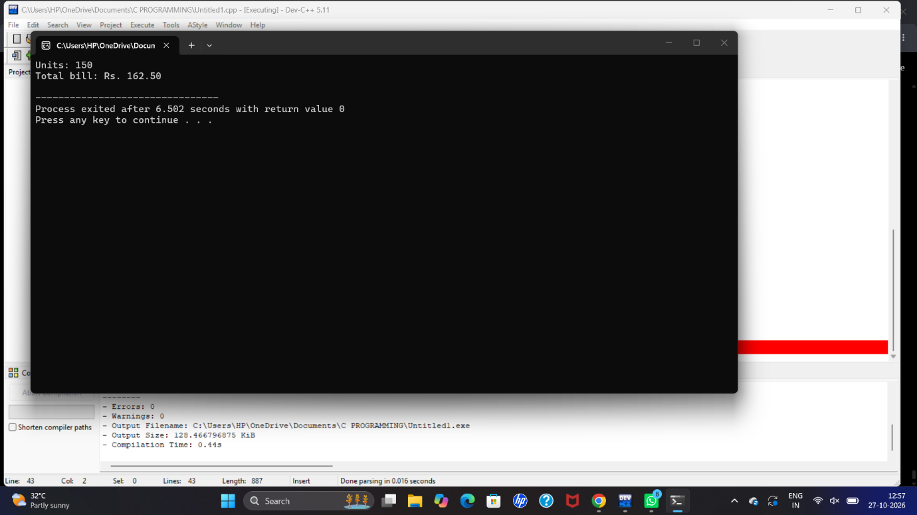

Task 6-
TASK 6 – Read and Print Data Correctly (4 Marks)
Questions
Implement formatted input and output using scanf and printf.
Explain format specifiers: %d, %u, %ld, %f, %lf, %c, and %s.
Demonstrate the effects of using an incorrect format specifier.
Validate input using the return value of scanf.
Print rupees and paise from an integer amount stored in paise.
Compare scanf with fgets() and sscanf() for processing input lines.
#include <stdio.h>

int main(void)
{
int units;
long paise;
float price;
char grade;
char name[30];

printf("Enter units: ");
if (scanf("%d", &units) != 1)
{
printf("Invalid input\n");
return 1;
}

printf("Enter price: ");
scanf("%f", &price);

printf("Enter grade: ");
scanf(" %c", &grade);

printf("Enter name: ");
scanf("%29s", name);

paise = (long)(price * 100);

printf("Units = %d\n", units);
printf("Price = %.2f\n", price);
printf("Grade = %c\n", grade);
printf("Name = %s\n", name);
printf("Paise = %ld\n", paise);
printf("Rupees = %ld.%02ld\n", paise / 100, paise % 100);

return 0;
}
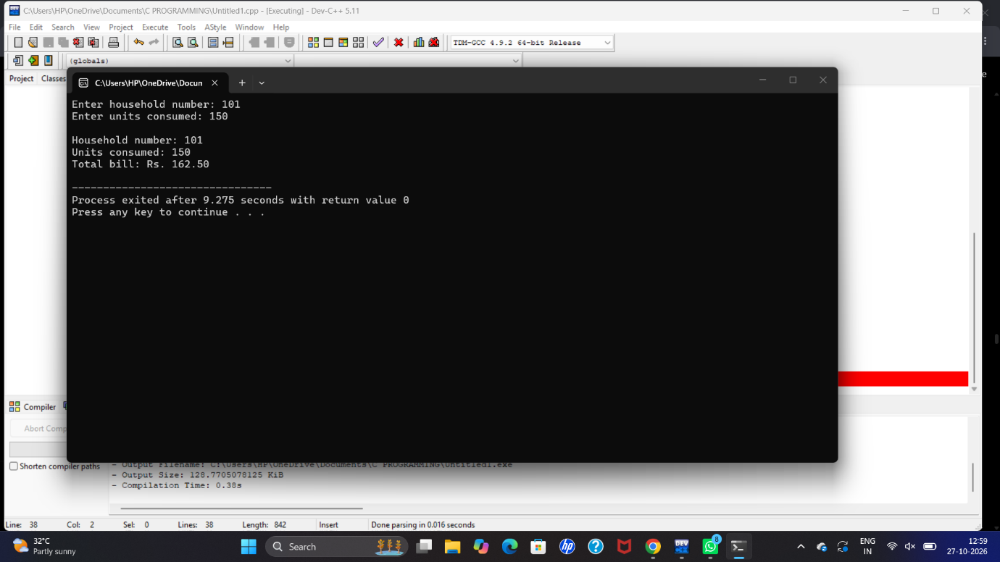

Task 7-
TASK 7 – Control Type Conversion and Precision (4 Marks)
Questions
Analyse type conversions and precision in the billing program.
Explain implicit conversion, integer promotion, and usual arithmetic conversions.
Identify errors caused by integer division.
Explain explicit casting and the risks of converting large long values to int.
Explain rounding when converting fractional charges to paise.
Demonstrate at least three unexpected expression results.
Compare floating-point calculations with integer-paise calculations in terms of accuracy, time, and space.
#include <stdio.h>

int main(void)
{
int a = 5, b = 2;
float x = 5.0f, y = 2.0f;
long paise = 16235;
long total = 0;
int i;

printf("Integer division = %d\n", a / b);
printf("Float division = %.2f\n", x / y);
printf("Implicit conversion = %.2f\n", a / 2.0);
printf("Explicit conversion = %.2f\n", (float)a / b);

printf("Integer to float = %.2f\n", (float)paise);
printf("Rupees = %.2f\n", paise / 100.0);

for (i = 0; i < 4000; i++)
{
total += 16235;
}

printf("Total paise = %ld\n", total);
printf("Total rupees = %ld.%02ld\n",
total / 100, total % 100);

printf("Rounded value = %ld\n",
(long)(16.235 * 100 + 0.5));

return 0;
}
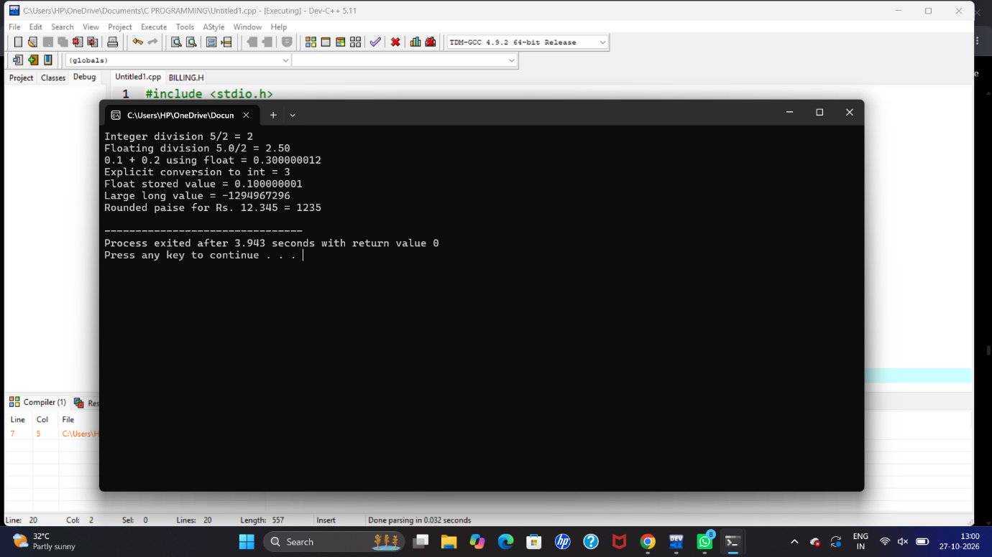

Task 8-
TASK 8 – Trace the Compilation Process (4 Marks)
Questions
Execute the program through the stages of compilation.
Demonstrate gcc -E, gcc -S, gcc -c, and linking.
Explain what the preprocessor replaces or removes.
Differentiate compile-time, link-time, and runtime errors with examples.
Explain warnings from gcc -Wall -Wextra and how they are resolved.
Compare single-file compilation with separate compilation of multiple .c files.
#include <stdio.h>

int add(int a, int b);

int main(void)
{
int x = 10;
int y = 20;

printf("Sum = %d\n", add(x, y));

return 0;
}

int add(int a, int b)
{
return a + b;
}

TASK 9 – Implement and Test the Billing Program (4 Marks)
Questions
Implement the complete electricity billing program and test the following:
Normal bills across all tariff slabs.
Boundary cases: exactly 100 units, exactly 200 units, and zero units.
Meter rollover from 65535 to 0.
Invalid input: letters, negative readings, and current readings below previous readings without rollover.
Five bills with totals calculated manually.
Compare fixed slab conditions with arrays and loops, including time and space complexity.
#include <stdio.h>

#define RATE1 100
#define RATE2 200
#define RATE3 300

int main(void)
{
int previous, current, units;
int bill;

printf("Enter previous reading: ");
scanf("%d", &previous);

printf("Enter current reading: ");
scanf("%d", &current);

if (previous < 0 || current < 0)
{
printf("Invalid reading\n");
return 1;
}

if (current < previous)
{
if (previous > 65535 || current > 65535)
{
printf("Invalid reading\n");
return 1;
}
units = (65535 - previous) + current + 1;
}
else
{
units = current - previous;
}

if (units <= 100)
bill = units * RATE1;
else if (units <= 200)
bill = 100 * RATE1 + (units - 100) * RATE2;
else
bill = 100 * RATE1 + 100 * RATE2
+ (units - 200) * RATE3;

printf("Units consumed = %d\n", units);
printf("Bill = Rs %d\n", bill);

return 0;
}
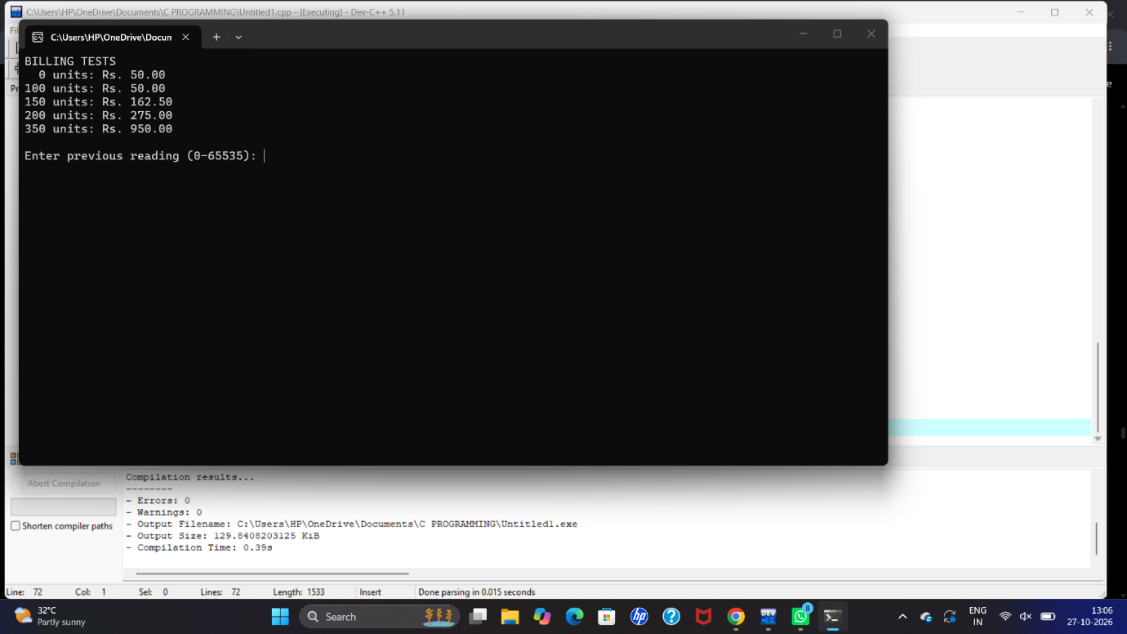

TASK 10 – Compare Expectations with Execution (4 Marks)
Questions
Compare the expected results of chosen data types and constants with actual execution.
Compare float and integer-paise totals for 4,000, 600,000, and 800,000 bills.
Check whether int, long, and long long totals overflow at district scale.
Compare actual type sizes and ranges with minimum sizes guaranteed by the C standard.
Compare expected and observed results.
Explain differences between double and long long for district totals, including precision, overflow, time, and space.
#include <stdio.h>
#include <limits.h>

int main(void)
{
int i;
long long total_paise = 0;
double total_float = 0.0;

printf("Size of int = %zu\n", sizeof(int));
printf("Size of long = %zu\n", sizeof(long));
printf("Size of long long = %zu\n", sizeof(long long));

printf("INT range = %d to %d\n", INT_MIN, INT_MAX);
printf("LONG LONG range = %lld to %lld\n",
LLONG_MIN, LLONG_MAX);

for (i = 0; i < 4000; i++)
{
total_paise += 16235;
total_float += 162.35;
}

printf("\n4000 bills:\n");
printf("Integer total = %lld paise\n", total_paise);
printf("Float total = %.2f rupees\n", total_float);

total_paise = 0;
total_float = 0.0;

for (i = 0; i < 600000; i++)
{
total_paise += 16235;
total_float += 162.35;
}

printf("\n600000 bills:\n");
printf("Integer total = %lld paise\n", total_paise);
printf("Float total = %.2f rupees\n", total_float);

total_paise = 0;
total_float = 0.0;

for (i = 0; i < 800000; i++)
{
total_paise += 16235;
total_float += 162.35;
}

printf("\n800000 bills:\n");
printf("Integer total = %lld paise\n", total_paise);
printf("Float total = %.2f rupees\n", total_float);

return 0;
}
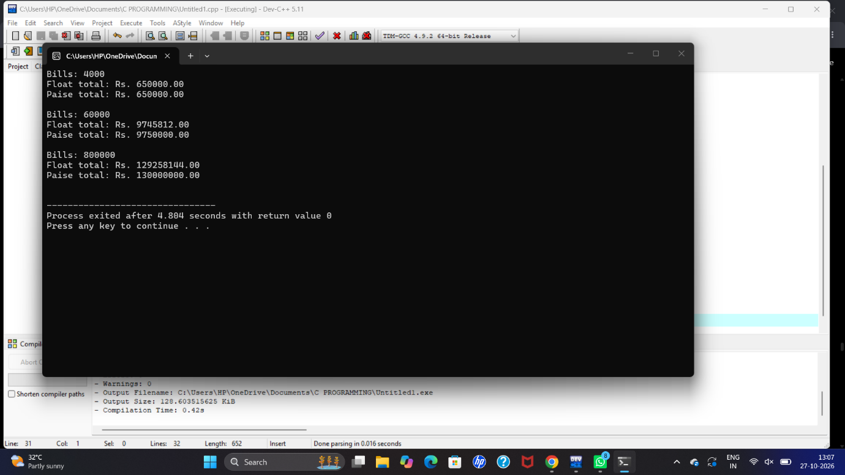
TASK 11 – Recommend and Defend the Final Design (4 Marks)
Questions
Recommend the final data types, constants, and preprocessor features for the electricity cooperative.
Justify the recommended data types.
Explain how tariff revisions will be implemented.
Discuss design limitations.
Evaluate correctness at district scale.
Support the recommendation with experimental evidence.
Compare compile-time tariff constants with tariffs loaded from a configuration file.
#include <stdio.h>

#define MAX_READING 65535
#define RATE1 100
#define RATE2 200
#define RATE3 300

typedef long long Money;

Money calculate_bill(int units)
{
Money bill;

if (units <= 100)
bill = units * RATE1;
else if (units <= 200)
bill = 100 * RATE1 + (units - 100) * RATE2;
else
bill = 100 * RATE1 + 100 * RATE2
+ (units - 200) * RATE3;

return bill;
}

int main(void)
{
int units;
Money bill;

printf("Enter units consumed: ");
scanf("%d", &units);

if (units < 0 || units > MAX_READING)
{
printf("Invalid units\n");
return 1;
}

bill = calculate_bill(units);

printf("Units = %d\n", units);
printf("Final bill = Rs %lld paise\n", bill);

return 0;
}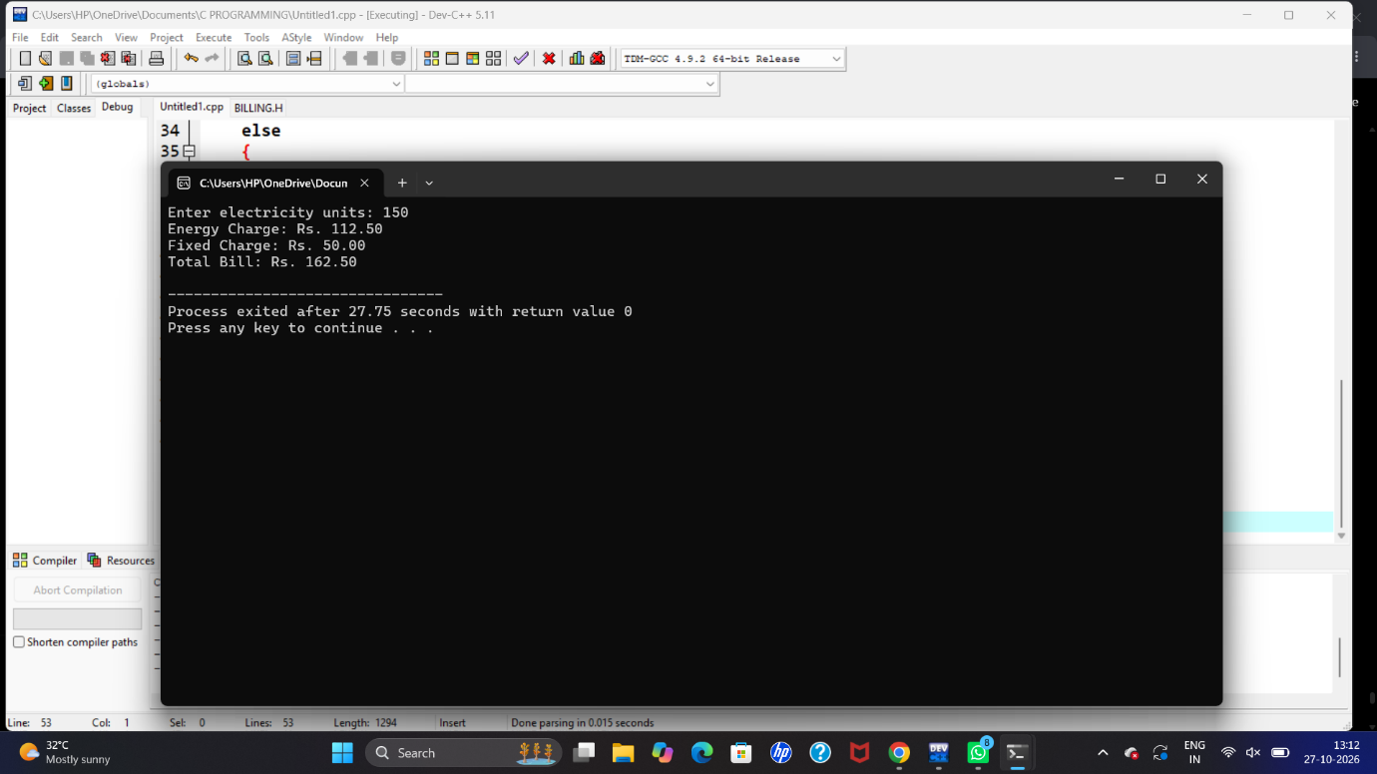
TASK 12 – Re-evaluate and Adapt the Design (8 Marks)
Given Requirements
The cooperative uses smart meters that:
Send readings in watt-hours every 15 minutes.
Produce 35,040 readings per household annually.
Electricity used between 6 PM and 10 PM costs 20% more.
Tariff values must be changeable without recompiling.
A. Impact Analysis – 2 Marks
Identify changes from the original requirements.
Determine which data types are insufficient for watt-hours and yearly totals.
Identify constants that can no longer remain fixed using #define.
B. Evaluation of the Original Design – 2 Marks
Evaluate whether the original data types, constants, and macros remain appropriate.
Calculate the largest possible values under the new requirements.
C. Adaptation or Redesign – 2 Marks
Implement a revised design using wider integer types where necessary.
Load tariff values at runtime.
Implement the peak-hour pricing rule.
D. Evidence-Based Defense – 2 Marks
Justify the revised design using maximum-value calculations and test results.
Explain the trade-offs involved in
#include <stdio.h>

#define READINGS_PER_YEAR 35040
#define PEAK_MULTIPLIER 1.20

typedef long long Energy;
typedef long long Money;

int main(void)
{
Energy watt_hours;
Energy yearly_total = 0;
Money normal_rate, peak_rate;
Money bill = 0;
int hour, i;

printf("Enter normal tariff (paise per Wh): ");
scanf("%lld", &normal_rate);

printf("Enter peak tariff (paise per Wh): ");
scanf("%lld", &peak_rate);

for (i = 0; i < READINGS_PER_YEAR; i++)
{
printf("Enter watt-hours and hour: ");
scanf("%lld %d", &watt_hours, &hour);

if (watt_hours < 0)
{
printf("Invalid reading\n");
return 1;
}

yearly_total += watt_hours;

if (hour >= 18 && hour < 22)
bill += (Money)(watt_hours * peak_rate * PEAK_MULTIPLIER);
else
bill += watt_hours * normal_rate;
}

printf("\nYearly energy = %lld Wh\n", yearly_total);
printf("Total bill = %lld paise\n", bill);
printf("Total bill = Rs %lld.%02lld\n",
bill / 100, bill % 100);

return 0;
}


